Worksheet 01

**Fits all sizes**

Go to <http://expo.getbootstrap.com/> and look at some featured websites that use the Bootstrap framework.

We will be using **Netbeans IDE 8.2** to develop the HTML pages in this problem and the Apache Web Server in **XAMPP** to serve the web pages. If you do not have the Netbeans tool or XAMPP, you can download it from the LEO supplementary learning path **‘Resources’**.

Also, you need to create a new PHP project called **C273_L01Bootstrap**. Refer to **NetBeans IDE PHP Project.docx** in LEO ‘Resources’

# HTML template using Bootstrap

1. **TODO:** Create a HTML file called **template.html**.Follow the instructions in the document **Web templates.docx** in LEO ‘Resources’ to create an offline Bootstrap web template.
2. Run the file and observe what does <div class=container>…<div> do to the content of the page? (Remember to start XAMPP and start the Apache Web Server)

# Bootstrap Grid System

In graphic design, a grid is a structure (usually two-dimensional) made up of a series of intersecting straight (vertical, horizontal) lines used to structure content. It is widely used to design layout and content structure in print design. In web design, it is a very effective method to create a consistent layout rapidly and effectively using HTML and CSS.

<http://en.wikipedia.org/wiki/Grid_%28graphic_design%29>

Open <https://www.drinksoma.com/> in your web browser, try resizing your browser to view the effects of the images.

**Resources**:

<https://www.w3schools.com/bootstrap4/bootstrap_grid_basic.asp>

<https://www.sitepoint.com/understanding-bootstrap-grid-system/>

<https://bootstrapcreative.com/bootstrap-4-grid-explained-examples/>

1. **TODO:** Create a new HTML file called **1_grid.html**. Add the styling code below within the <head> section of your file, for the purpose of viewing the grid items clearly.

|  |
| --- |
| <style type="text/css">  .pink {  background: pink;  border: 1px solid purple;  }  .orange {  background: orange;  border: 1px dashed red;  height: 50px;  }  </style> |

1. **TODO**: Add the code below within the <body> section of your file, to create a row with 2 equal columns.

|  |  |
| --- | --- |
| **10**  **11**  **12**  **13**  **14**  **15**  **16**  **17**  **18**  **19** | <div class="container">  <div class="row">  <div class="col pink">COL</div>  <div class="col pink">COL</div>  </div>  <div class="row">  <div class="col-md-6 pink">COL</div>  <div class="col-md-6 pink">COL</div>  </div>  </div> |

Line 10 – The “container” class is added to ensure proper centering and maximum width for layout.

Line 11 – Once container is added, next you need think in terms of rows. Every “row” class represents one row.

Line 12-13 - “col” class represents one column. Two “col” elements = 50% width to each col.

Line 16-17 – Every “col-*-*” class represents one column and is added inside the row. The first star (*) represents the responsiveness: sm, md, lg or xl, while the second star represents a number, which should always add up to **12 units** for each row. In our example we have two columns each made of 6 units wide i.e 6+6=12.

The Bootstrap 4 grid system has five classes:

* .col- (extra small devices - screen width less than 576px)
* .col-sm- (small devices - screen width equal to or greater than 576px)
* .col-md- (medium devices - screen width equal to or greater than 768px)
* .col-lg- (large devices - screen width equal to or greater than 992px)
* .col-xl- (xlarge devices - screen width equal to or greater than 1200px)

The classes above can be combined to create more dynamic and flexible layouts.

**Tip:** Each class scales up, so if you wish to set the same widths for sm and md, you only need to specify sm.

Run 1_grid.html and describe what you see:

|  |
| --- |
| I can see two rows and two columns of the word "COL" on the web page. |

Try resizing your browser to < 768px (extra small or small devices) and observe what happens.

|  |
| --- |
| As it is resized to < 768px, the first row of words will remain the same, being adjscent to one another. Whereas for the second row, since it is made for medium-sized devices, for a 6-column in a medium-sized unit, it will pull one "COL" down to another row when it is resized < 768px. |

1. Try out the following scenarios:

**TODO**: Write code to display the following on **medium** **devices**:



25%

75%

Cut & paste your code here

|  |
| --- |
|  |

**TODO**: Write code to display the following on **medium** **devices**:



50%

25%

25%

Cut & paste your code here

|  |
| --- |
|  |

**TODO**: Write code to display the following on **medium** **devices**:



25%

75%

Cut & paste your code here

|  |
| --- |
|  |

**TODO**: Write code to display the following on **medium devices**:

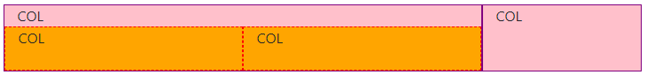

25%

75%

Cut & paste your code here

|  |
| --- |
|  |

1. Repeat the scenarios, but for display on all devices: extra small, small, large and extra-large devices. Test on your browser by resizing it.
2. What if you want a site that has:
   * 1 column on mobile phone (extra small devices)
   * 2 columns on tablet (small devices)
   * 4 columns on desktop (medium devices)

The grid system now cascades up from mobile devices. This is how the code looks like:

|  |
| --- |
| <div class="row">  <div class="col-sm-6 col-md-3 pink">COL</div>  <div class="col-sm-6 col-md-3 pink">COL</div>  <div class="col-sm-6 col-md-3 pink">COL</div>  <div class="col-sm-6 col-md-3 pink">COL</div>  </div> |

Add this code to index.php and run it. Resize your browser to see the effect.

Note: You do not need to specify “col-12” for extra small devices because the default is 1 column.

**TODO**: Write code to display the following:

* + 2 columns on small devices
  + 3 columns on medium devices
  + 6 columns on large devices

Cut & paste your code here

|  |
| --- |
|  |

# Bootstrap Typography and Spacing Utilities

**Resources:**

<https://www.w3schools.com/bootstrap4/bootstrap_typography.asp>

<https://www.w3schools.com/bootstrap4/bootstrap_ref_all_classes.asp>

1. **TODO:** Create a new HTML file with basic Bootstrap with Font Awesome web template (offline) called **2_text_spacing.html** and write code to create a page like below.

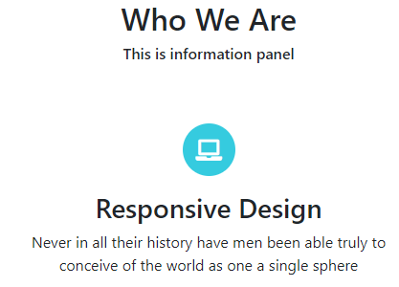

You can use the following HTML code as starter code:

|  |
| --- |
| <div>  <h2>Who We Are</h2>  <h6>This is information panel</h6>  </div>  <div>  <h3>Responsive Design</h3>  <p>Never in all their history have men been able truly to conceive of the world as one a single sphere</p>  </div> |

For the solid circle with blue background, you can use the following style:

|  |
| --- |
| .box-circle-solid{  background-color:#35CBDF;  border-radius: 50%;  color: #fff;  font-size: 22px;  height: 55px;  line-height: 55px;  text-align: center;  width: 55px;  } |

* To insert a Font Awesome icon, you can use the following code:

|  |
| --- |
| <i class="fa fa-laptop"></i> |

See Font Awesome gallery of icons here <https://fontawesome.com/icons?d=gallery>

* You need to use Bootstrap Spacing Utilities to create margin or padding between content. <https://getbootstrap.com/docs/4.0/utilities/spacing/>

1. You can make text to be aligned to the centre by using the class **text-center**. To set the margin at the bottom to 3 times the size of $spacer, you can use mb-5. Study the code example below.

|  |
| --- |
| <div class="text-center">  <i class="fa fa-laptop box-circle-solid mt-3 mb-3"></i>  <h3>Responsive Design</h3>  </div> |

1. What other Bootstrap Spacing Utilities classes were used in this page?

|  |
| --- |
| Options for Horizontal Centering |

# Bootstrap Tables

**Resources:** <https://getbootstrap.com/docs/4.1/content/tables/>

1. **TODO:** Create a new HTML file with basic Bootstrap called **3_tables.html** and write code to create the following tables:

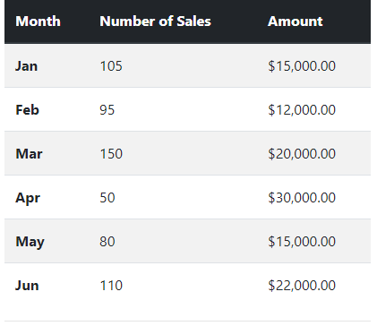

Diagram D_1

1. What are the table classes used for Diagram D_1?

|  |
| --- |
| Options for the table head. |

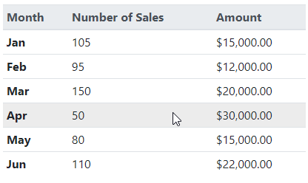

Diagram D_2

1. What are the table classes used for Diagram D_2?

|  |
| --- |
| Optional table head with hoverable rows. |

# Bootstrap Cards and Images

**Resources:** <https://getbootstrap.com/docs/4.1/components/card/>

<https://getbootstrap.com/docs/4.1/content/images/>

1. **TODO:** Create a new HTML file with basic Bootstrap called **4_cards_images.html**. Write the following code in the body of the HTML.

|  |
| --- |
| <div class="card text-white bg-primary mb-3" style="max-width: 18rem;">  <div class="card-header">Header</div>  <div class="card-body">  <h5 class="card-title">Primary card title</h5>  <p class="card-text">What do you see?</p>  </div>  </div> |

1. Paste the screenshot of the card produced.

|  |
| --- |
|  |

1. Nowwrite code to create the following page:



Diagram E_1

1. What Bootstrap classes were used in this page?

|  |
| --- |
| Background Color |

# Solution: Completing the webpages

1. **TODO:** Create a new HTML file with basic Bootstrap with Font Awesome web template called **about.html** and write code to create a page like below.

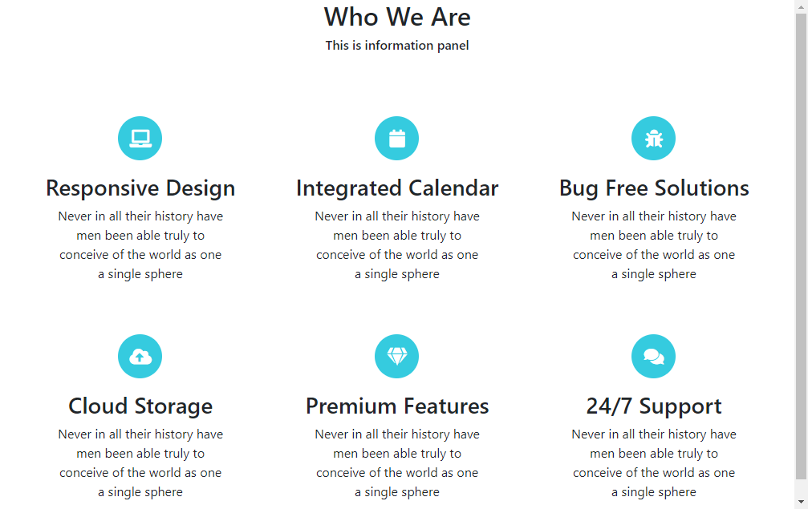

* Make sure that the page is responsive and displays 3 columns on large devices, 2 columns on small devices and 1 column on extra small devices.

1. **TODO:** Create a new HTML file with basic Bootstrap with Font Awesome web template called **team.html** and write code to create a page like below with 3 images. See <https://getbootstrap.com/docs/4.0/content/images/>



1. **TODO:** Create a new HTML file with basic Bootstrap with Font Awesome web template called **contact.html** and write code to create a page like below.



* See List Icons in <https://fontawesome.com/> to replace the bullets in a list with Font Awesome icons.

1. **TODO:** Create a new HTML file with basic Bootstrap with Font Awesome web template called **testimonials.html** and write code to create a page like below with 3 cards and a table.



# Challenge Yourself

* Combine about.html, team.html, story.html and company.html into a single web page, dividing them into sections

* Add a Bootstrap Navbar (See <https://getbootstrap.com/docs/4.0/components/navbar/>) that looks like below:



* Create anchor links (<http://www.echoecho.com/htmllinks08.htm>) for each section and link them to each navbar menu item.
* Add a jumbotron (See <https://getbootstrap.com/docs/4.0/components/jumbotron/>) just after the navigation bar.
* Refer to solution.png for the final page.